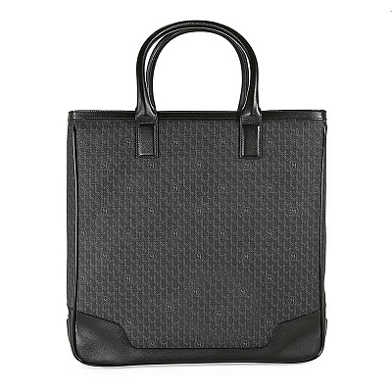

RYDER MINI SATCHEL

PRODUCT DETAILS

**Condition: New with tags: A brand-new, unused, and unworn item**

**(including handmade items) in the original packaging**

**(such as ... Read more**

**Size: Large**

**Closure: Zipper Color: Black & Gray**

**Depth: 11 cm Hardware Color: Black**

**Height: 38 cm Model: MB 106757**

**Material: Leather MPN: N/A**

**Brand: Montblanc Country/Region of Manufacture: Germany**

**Accents: Leather trim Montblanc Logo at the Top Style: Tote Bag**

**Features: Pocket for mobile phone, 3 writing instruments, 2 credit**

**cards, Snap Closure, Two Handles, Protective Bottom**

**with Three Rings Profile, Lined Leather protective sides**

**and bottom**

**UPC: 4017941573599**